Requirement Analysis Phase

✅ **1. Project Overview**

The House Hunt Project is a structured approach to finding a suitable residential property that meets the needs, preferences, and financial capacity of an individual or family. Whether the goal is to buy, rent, or invest, this project is designed to simplify and streamline the house hunting process using data-driven research, comparison techniques, and strategic planning.

👥 **2. Target Users**

|  |  |
| --- | --- |
| **User role** | **Description** |
| user | The main user actively looking to buy, rent, or invest in a property. This person drives the entire house hunting process. |
| Owner | The individual or entity that owns the property being listed for sale or rent. |

🎯 **3. Goals & Objectives**

* Identify and Understand User Requirements
* Establish a Clear and Realistic Budget
* Verify Legal Documents and Property Legitimacy
* Support Negotiation and Deal Finalization

⚙ **4. Functional Requirements**

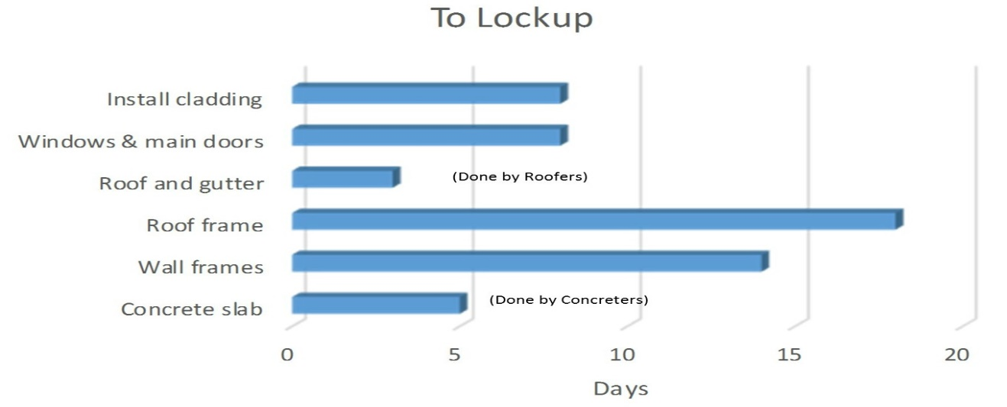

🚫 **5. Non-Functional Requirements**

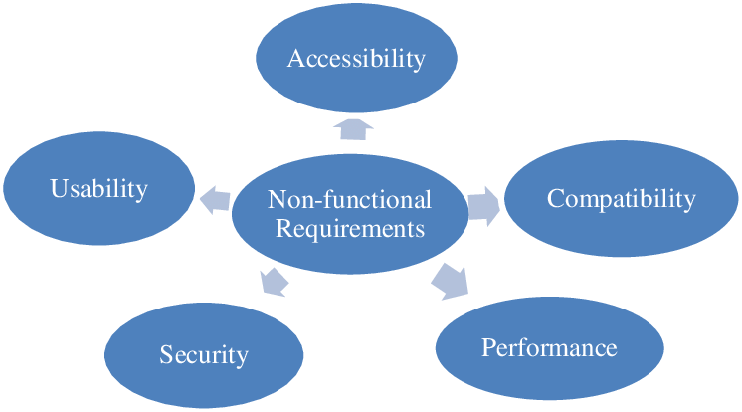

* **6. Tech Stack**

|  |  |
| --- | --- |
| **Layer** | **Technology** |
| Frontend | React, HTML, JavaScript |
| Backend | Node.js, Express.js |
| Database | MongoDB(via Mongoose) |
| Hosting | GitHub Pages(client), Render (Server) |
| Dev Tools | Vs code, Git, npm |

**📝 7. Future Enhancements**

* + AI-Based Property Recommendations
  + Instant Notifications & Smart Alerts
  + Digital Document Verification Tool
  + Helps users evaluate homes without physical visits
  + Home Loan Assistance
  + Verified Reviews and Ratings
  + 360° Virtual Tours